**PF Lab**

***Exercise # 1***

**Roll No: 23k-2001**

**Name: M.Muzammil Siddiqui**

**Q#1: Calculator using Scratch**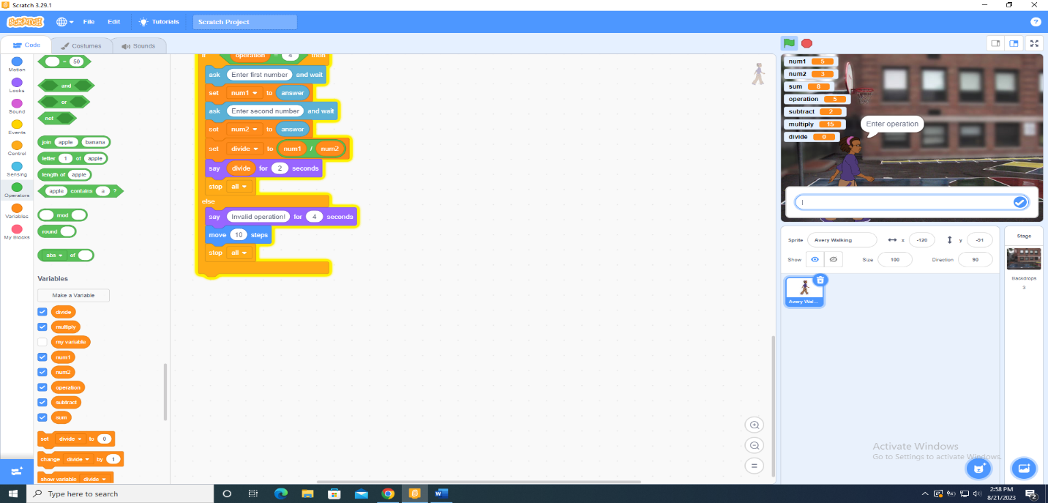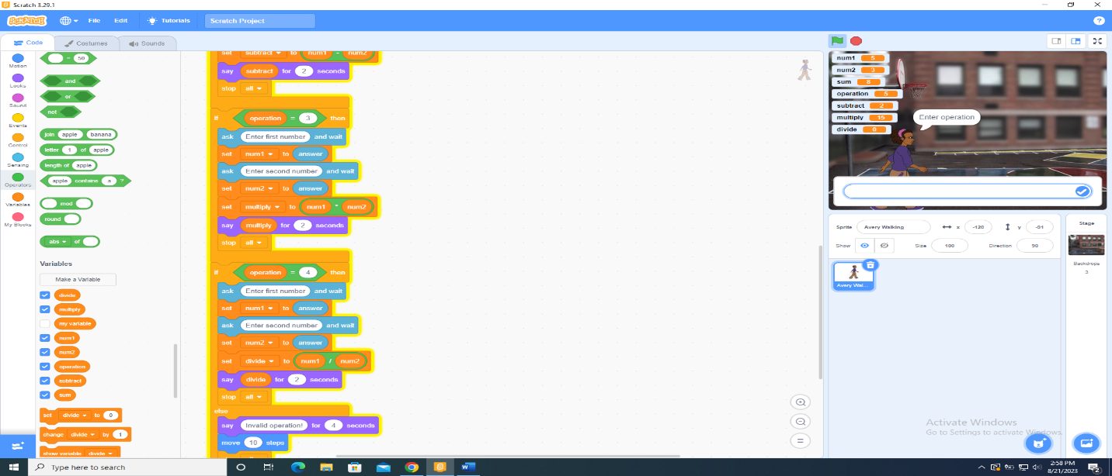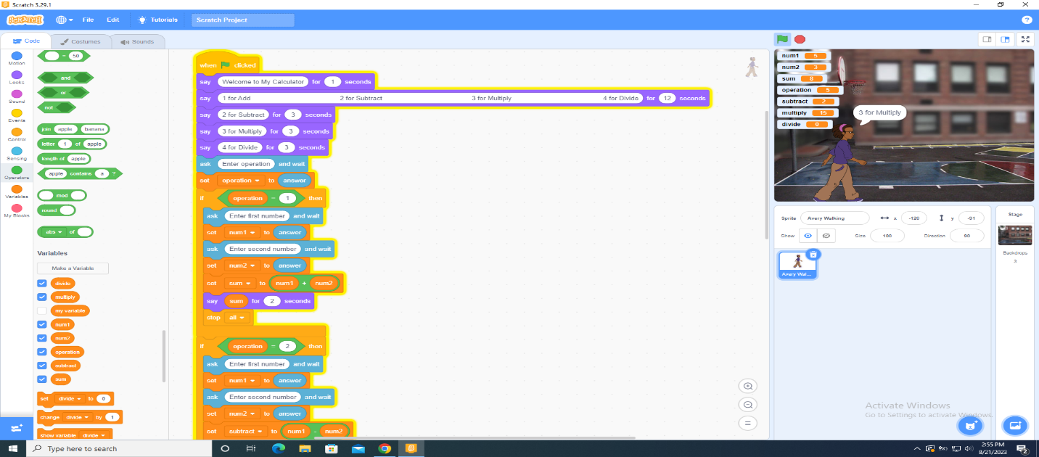

**Q#2: Find Volume of Container**

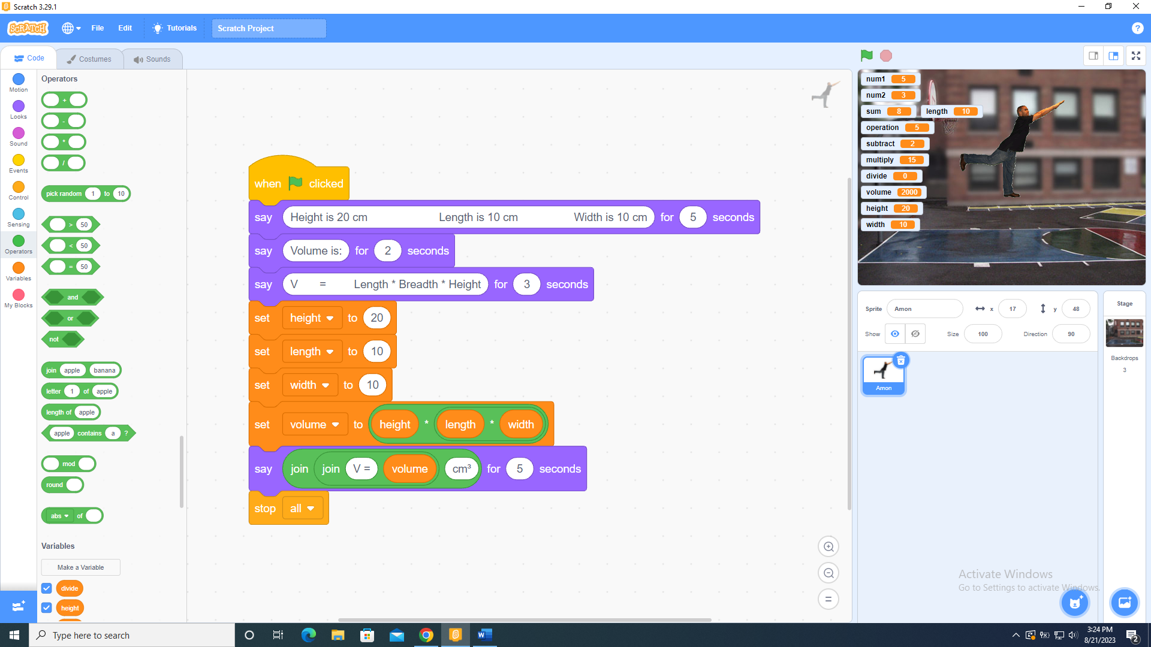

**Q#3: Find Hypotenuse**

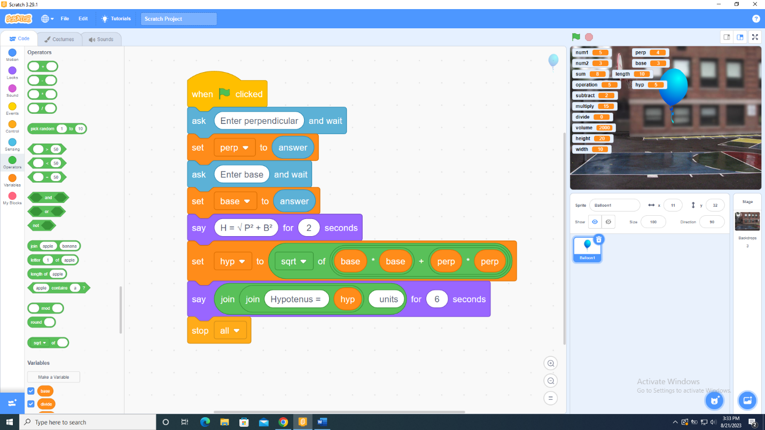

**Q#4: Find new price after discount**

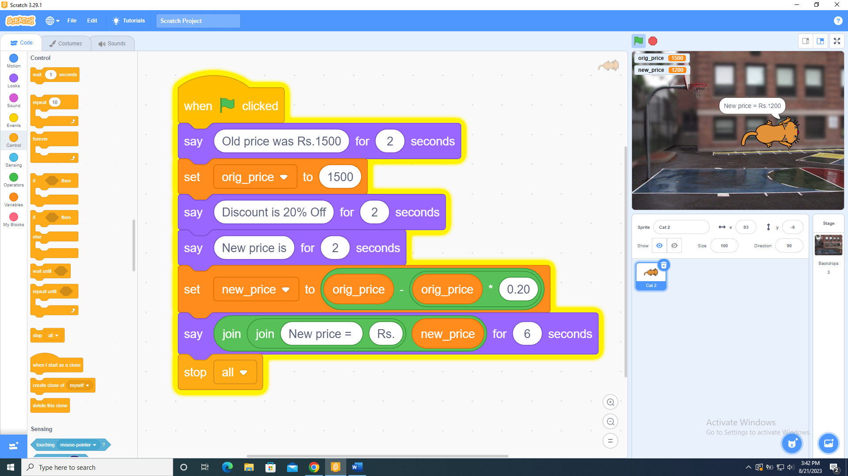

**Q#5: Calculate Distance and Fuel Consumption**

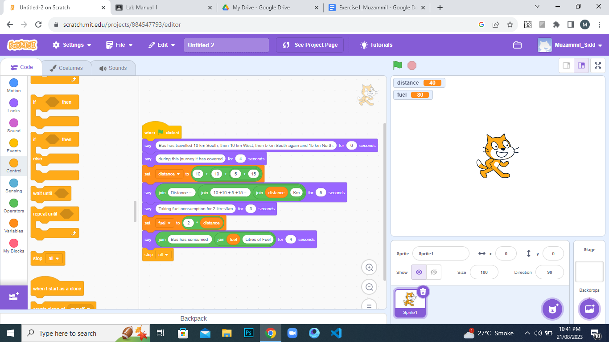

**Q#6: Calculate Hours Per Week**

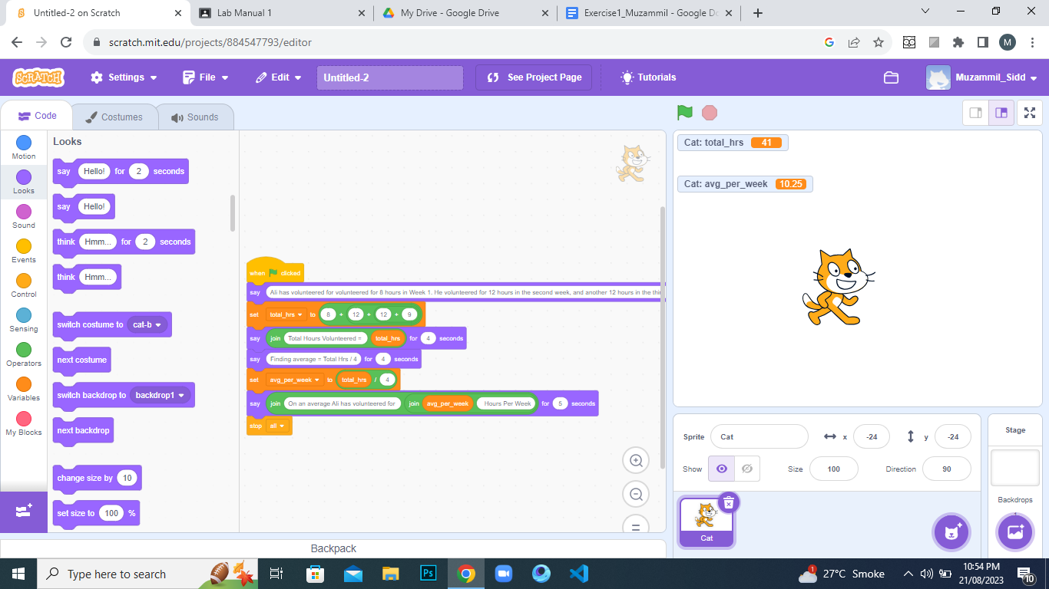

**Q#7: Distance between two points**

*[ using D = √((x 2 – x 1 ) 2 + (y 2 – y 1 ) 2 ) ]*